**Market Segmentation Analysis of Electric Vehicles in India**

* M Divyashree

08/10/2023

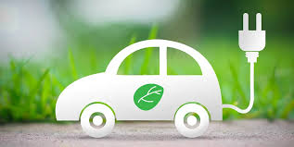

**Overview:**

Electric vehicles (EVs) use electric motors for propulsion, powered either externally or by batteries. They have a long history but gained renewed interest in the 21st century due to technological advancements and environmental concerns.

In India, the EV industry is in its early stages, accounting for less than 1% of total vehicle sales. However, it has the potential to grow to over 5% in the coming years. Currently, there are more than 500,000 electric two-wheelers and a few thousand electric cars on Indian roads.

The majority of electric vehicles in India are low-speed electric scooters that don't require registration or licenses. These scooters typically use lead batteries, but battery issues and limited lifespans are challenges. Some companies have attempted to establish charging stations with limited success.

**Problem Statement:**

"The Indian electric vehicle (EV) market is experiencing rapid growth and diversification. Therefore, the problem statement for this analysis is to identify and profile distinct market segments within the Indian EV market, based on consumer characteristics, preferences, and behavior. The goal is to provide actionable insights for EV manufacturers, policymakers, and other stakeholders to better serve the evolving needs and preferences of Indian EV consumers."

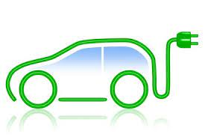

**Market segmentation**

Market segmentation is a fundamental concept in marketing that involves dividing a broad and diverse market into smaller, more manageable segments or groups of consumers who share similar characteristics and needs. When it comes to electric vehicle (EV) vehicles, market segmentation can be applied to identify and target different groups of potential EV buyers or users. Here's an overview of market segmentation theory and its application to EV vehicles:

The primary purpose of market segmentation is to understand the diverse needs and preferences of consumers within a market, allowing businesses to develop tailored marketing strategies and offerings.

Effective market segmentation provides several benefits, including increased marketing efficiency, higher customer satisfaction, improved product development, and enhanced brand positioning.

**Types of Market Segmentation:**

* Demographic Segmentation: Dividing the market based on demographic factors such as age, gender, income, education, and family size. For EVs, this could involve targeting segments like young professionals, families, or retirees.
* Psychographic Segmentation: Segmenting based on lifestyle, values, interests, and personality traits. This can help identify EV users who are environmentally conscious or tech-savvy.
* Behavioral Segmentation: Grouping consumers by their behaviors, including purchase history, brand loyalty, usage patterns, and attitudes toward EV technology. This can help target early adopters or brand-loyal customers.
* Geographic Segmentation: Segmenting based on geographical location, such as urban, suburban, or rural areas. Urban areas may have different EV adoption rates and charging infrastructure needs compared to rural areas.

**Application of EV Vehicles:**

* Customer Profiles: In the context of EV vehicles, market segmentation helps identify target customer profiles. For example, one segment might consist of eco-conscious consumers who prioritize sustainability, while another segment might include individuals looking for cost-effective transportation.
* Product Development: Understanding the needs of different segments can inform product development. For instance, a segment interested in long-range EVs may lead to the development of high-capacity battery models.
* Marketing Strategies: Tailored marketing strategies can be created for each segment. Messaging, advertising channels, and promotional activities can be adjusted to resonate with the specific needs and values of each segment.
* Pricing and Distribution: Segmentation can also impact pricing strategies and distribution channels. Some segments may be willing to pay a premium for certain EV features, while others may prioritize affordability.

In summary, market segmentation is a crucial concept in the marketing of EV vehicles. It helps businesses identify and cater to diverse consumer needs and preferences, ultimately leading to more effective marketing strategies and successful market penetration.

**Benefits of EV Vehicles**

* **Lower running costs**

The running cost of an electric vehicle is much lower than an equivalent petrol or diesel vehicle. Electric vehicles use electricity to charge their batteries instead of using fossil fuels like petrol or diesel. Electric vehicles are more efficient, and is cheaper than filling petrol or diesel for your travel requirements. Using renewable energy sources can make the use of electric vehicles more eco-friendly.

* **Low maintenance cost**

Electric vehicles have very low maintenance costs because they don’t have as many moving parts as an internal combustion vehicle. The servicing requirements for electric vehicles are lesser than the conventional petrol or diesel vehicles. Therefore, the yearly cost of running an electric vehicle is significantly low.

* **No noise pollution**

Electric vehicles have the silent functioning capability as there is no engine under the hood. No engine means no noise. The electric motor functions so silently that you need to peek into your instrument panel to check if it is ON. Electric vehicles are so silent that manufacturers have to add false sounds in order to make them safe for pedestrians.

* **Electric Vehicles are easy to drive and quiet**

Electric vehicles don’t have gears and are very convenient to drive. There are no complicated controls, just accelerate, brake, and steer. When you want to charge your vehicle, just plug it in to a home or public charger. Electric vehicles are also quiet, so they reduce noise pollution that traditional vehicles contribute to.

* **Convenience of charging at home**

Imagine being at a busy fuel station during peak hours, and you are getting late to reach your workplace. These problems can easily be overcome with an electric vehicle. Simply plug your vehicle in at your home charger for 4-5 hours before you plan to go. If you are able to get a charger where you park at home, it is very convenient to plan your journeys in advance. What if you forget to plug in your machine someday? Then you can easily take the help of fast chargers or even battery swapping services if you are on a two-wheeler on the road.

**Data Preprocessing**

Data preprocessing steps aim to prepare the dataset for clustering analysis by ensuring data completeness (removing missing values), selecting relevant features, and standardizing the features to make them suitable for use in clustering algorithms. These steps help ensure that the analysis is based on clean, relevant, and appropriately scaled data.

**Data Source:**

**Dataset 1**

Here's a brief explanation of each column in my dataset 1:

- `Brand`: The brand or manufacturer of the electric vehicle.

- `Model`: The specific model or variant of the electric vehicle.

- `AccelSec`: The acceleration time in seconds (e.g., 0-60 mph or 0-100 km/h).

- `TopSpeed_KmH`: The maximum achievable speed in kilometers per hour.

- `Range_Km`: The driving range of the electric vehicle on a single charge.

- `Efficiency_WhKm`: The energy efficiency measured in watt-hours per kilometer.

- `FastCharge_KmH`: The rate at which the vehicle can be fast-charged in kilometers per hour.

- `RapidCharge`: Indicates whether the vehicle supports rapid charging.

- `PowerTrain`: The type of powertrain or propulsion system used in the vehicle.

- `PlugType`: The type of plug used for charging the vehicle.

- `BodyStyle`: The body style or design of the vehicle (e.g., sedan, SUV, hatchback).

- `Segment`: The market segment or category to which the vehicle belongs.

- `Seats`: The number of seats in the vehicle.

- `PriceEuro`: The price of the vehicle in Euros.

- `inr(10e3)`: The price of the vehicle in Indian Rupees (scaled by a factor of 10,000).

These columns provide various attributes and characteristics of electric vehicles, which are essential for market segmentation and analysis.

**Important libraries**

Here are some of the different Python modules used in the analysis, along with brief explanations for each:

* Pandas:-Used for data manipulation and analysis. It provides data structures like DataFrames for handling structured data.
* sklearn (scikit-learn):-machine learning library that includes various tools for clustering, classification, regression, and more.
* Matplotlib:-A data visualization library for creating static, animated, or interactive visualizations in Python.
* StandardScaler (from sklearn.preprocessing):-Used for standardizing data, ensuring that features have a mean of 0 and standard deviation of 1.
* KMeans (from sklearn.cluster):-Implements the K-Means clustering algorithm for partitioning data into clusters.
* Elbow Method (for determining optimal k):-A technique for finding the optimal number of clusters in K-Means by analyzing the Within-Cluster Sum of Squares (WCSS).
* matplotlib.pyplot:-A submodule of Matplotlib used for creating various types of plots and visualizations.
* NumPy:-A fundamental package for scientific computing in Python, providing support for arrays and matrices.
* seaborn:-A data visualization library based on Matplotlib that provides a high-level interface for creating attractive and informative statistical graphics.

These modules collectively facilitate data preprocessing, clustering, visualization, and analysis tasks in Python.

**Dataset 2**

This dataset at hand offers valuable insights into the distribution of various types of vehicles across different states. It includes data on two-wheelers, three-wheelers, passenger cars, and buses, categorized according to specific motor vehicle rules and regulations. This dataset reveals the significant disparities in vehicle counts among states, shedding light on regional preferences and transportation patterns. For instance, populous states like Andhra Pradesh and Delhi exhibit a high concentration of passenger cars, while states like Assam and Bihar favor two-wheelers as a primary mode of transport. Chhattisgarh stands out with a substantial presence of buses, suggesting a reliance on public transportation. Such data is indispensable for market segmentation and decision-making processes within the automotive industry, allowing for targeted strategies based on regional preferences and demands.

Here's a brief explanation of each column in my dataset 2:

- `Sl. No`: A serial number or identifier for each state.

- `State`: The name of each Indian state.

- `Two Wheelers (Category L1 & L2 as per Central Motor Vehicles Rules)`: The count of two-wheelers falling under categories L1 and L2 as per Central Motor Vehicles Rules.

- `Two Wheelers (Category L2 (CMVR))`: The count of two-wheelers falling under category L2 according to CMVR.

- `Two Wheelers (Max power not exceeding 250 Watts)`: The count of two-wheelers with a maximum power not exceeding 250 Watts.

- `Three Wheelers (Category L5 slow speed as per CMVR)`: The count of three-wheelers falling under category L5 with slow speed as per CMVR.

- `Three Wheelers (Category L5 as per CMVR)`: The count of three-wheelers falling under category L5 according to CMVR.

- `Passenger Cars (Category M1 as per CMVR)`: The count of passenger cars falling under category M1 as per CMVR.

- `Buses`: The count of buses in each state.

- `Total in state`: The total count of vehicles in each state.

**Data Cleaning:**

Data cleaning involves identifying and handling missing or incomplete data points in the dataset. This means that any rows or columns containing missing data were either deleted or filled in a way that does not introduce bias into the analysis

**Feature Selection:**

Feature selection refers to the process of choosing which features from the dataset will be used in the analysis. It's essential to select only the most relevant features that are likely to have a meaningful impact on the segmentation analysis.

**Standardization:**

Standardization is a data preprocessing technique used to ensure that all the selected features are on the same scale. Standardization is important when using distance-based clustering algorithms like K-Means because it prevents features with larger scales from dominating the clustering process.

**Visualizations**

DATASET 1

1)The following plot shows the Efficiency achieved by different brands.

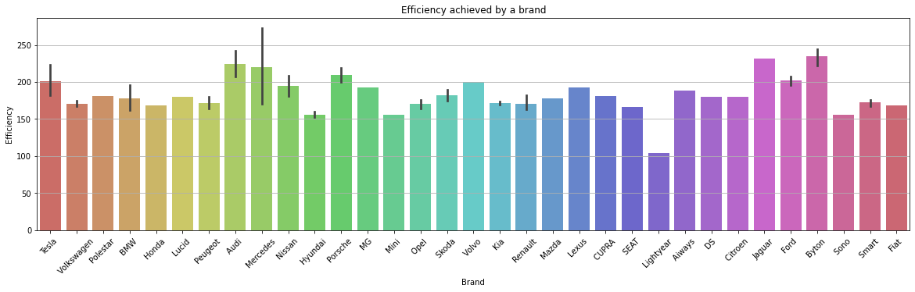

2)The following plot shows the price of every car in INR.

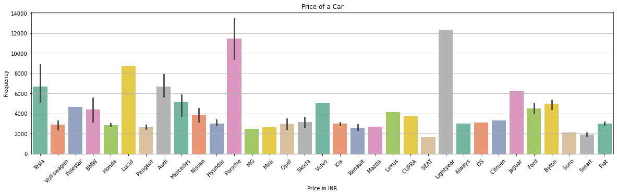

3)The following plot shows the Maximum Range achieved by different brands.

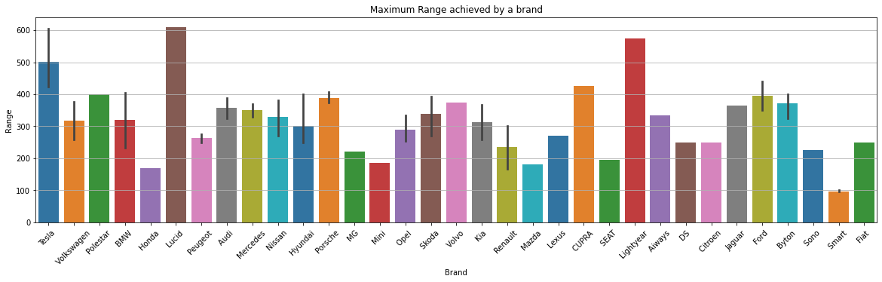

4)The following plot shows the number of seats in every car.

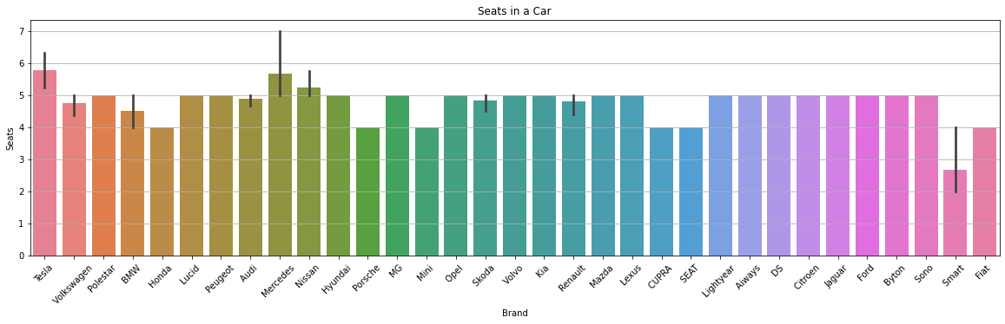

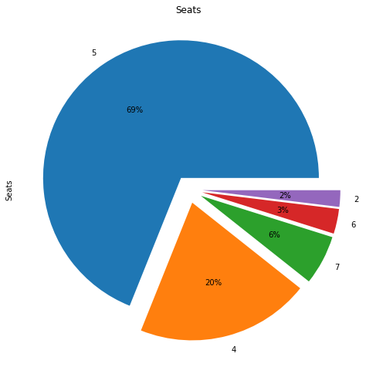

5)Pairplot of all the columns based on Rapid Charger presence

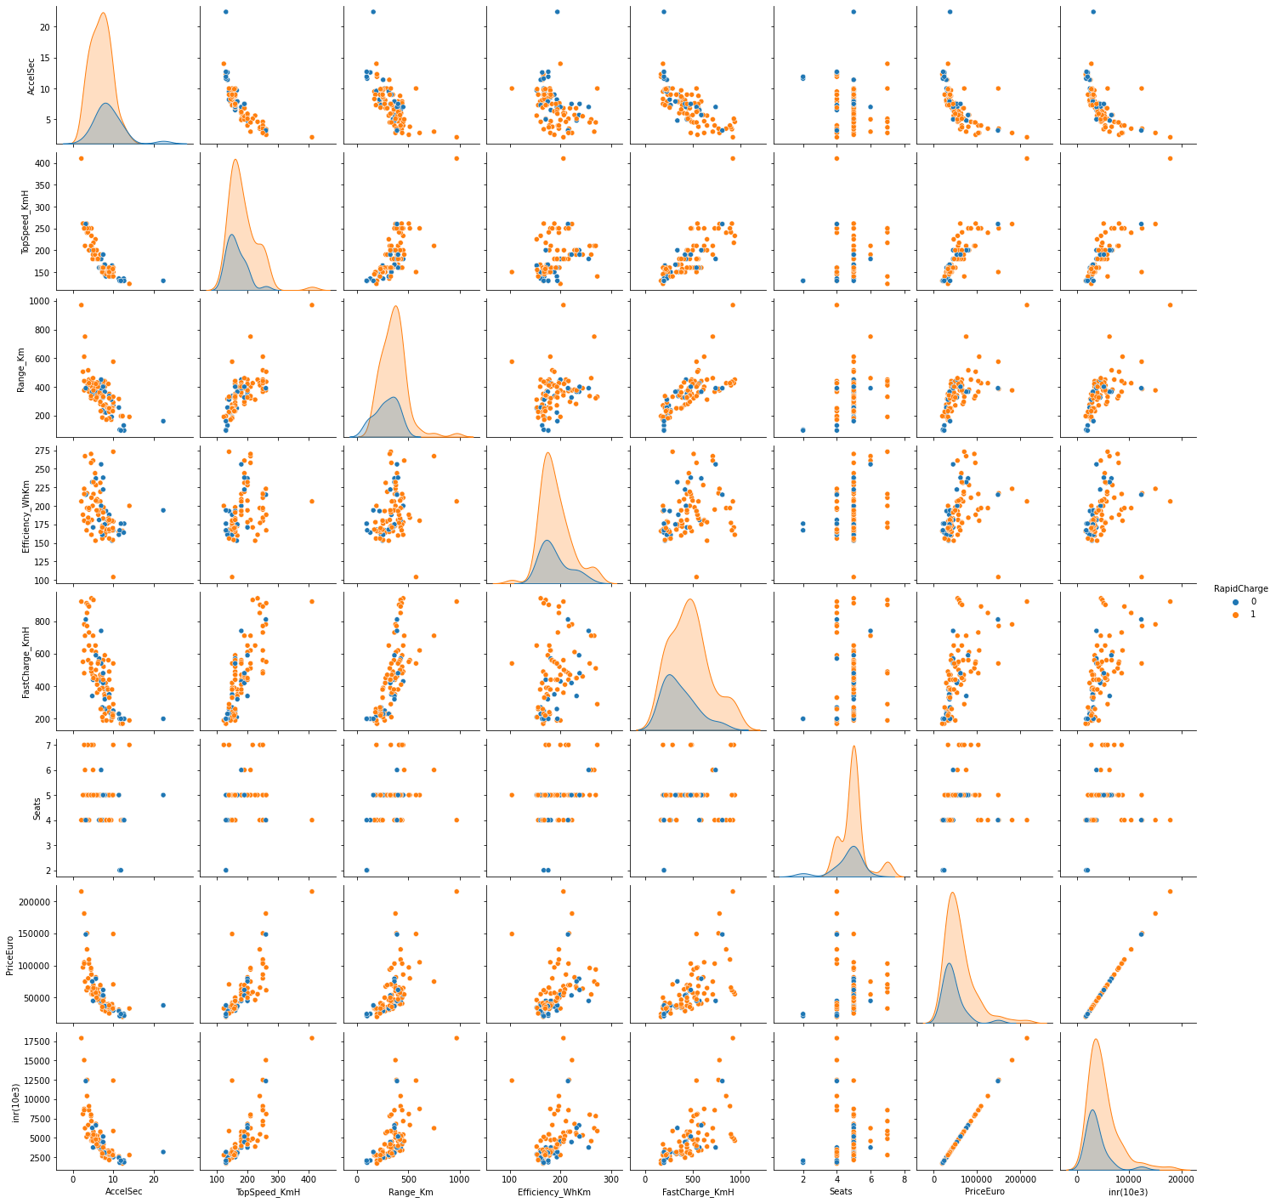

**DATASET 2**

The following plots were obtained from Dataset 2:

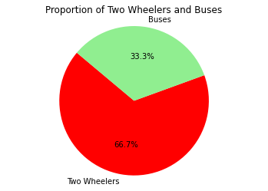

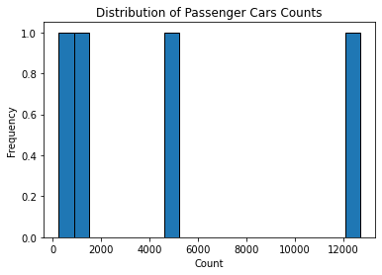

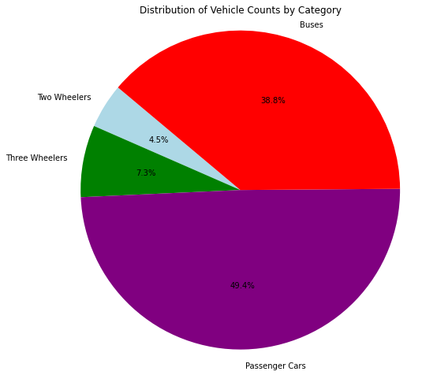

**K-Means clustering**

K-Means clustering is a widely used unsupervised machine learning algorithm that is used to partition a dataset into groups or clusters based on the similarity of data points. Here's a detailed explanation of how K-Means clustering works:

The main goal of K-Means clustering is to divide a dataset into K clusters, where each cluster represents a group of data points that are similar to each other and dissimilar to data points in other clusters.

After clustering is complete, we can interpret the clusters by examining the characteristics of data points within each cluster.

Assign meaningful labels or descriptions to clusters based on the common features of data points in each cluster.

**Advantages:**

* K-Means clustering is a partitional clustering algorithm, meaning it divides data into non-overlapping clusters.
* It is efficient and computationally scalable, making it suitable for large datasets.
* The algorithm's performance can be influenced by the choice of K and the initial placement of centroids.
* K-Means assumes that clusters are spherical, equally sized, and have similar densities, which may not hold in all cases.

**Uses**

* K-Means is widely used for customer segmentation, image compression, anomaly detection, recommendation systems, and more.
* It is an essential tool in exploratory data analysis and data preprocessing.

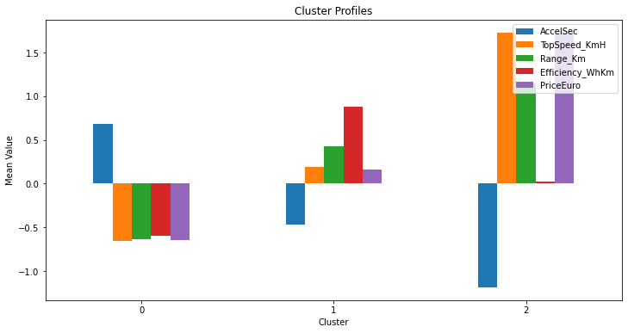

**Segment Profiling**

We have performed K-Means clustering to create distinct clusters of electric vehicles based on attributes like acceleration, top speed, range, price, and seating capacity. Now, segment profiling involves analyzing and understanding each of these clusters in detail:

1. Cluster Characteristics

- Begin by examining the characteristics of each cluster. Calculate the mean or median values for each attribute within each cluster. For example:

- Cluster 0 (High-Performance EVs) may have low acceleration times, high top speeds, high prices, and fewer seats.

- Cluster 1 (Mid-Range EVs) may have moderate values for acceleration, top speed, and price, and moderate seating capacity.

- Cluster 2 (Budget-Friendly EVs) may have slower acceleration, lower top speeds, lower prices, and more seats.

2. Demographics:

- If you have access to demographic data for your customers or target audience, you can profile each cluster in terms of the demographics of the customers who prefer each cluster.

- Cluster 0 might attract younger, high-income individuals who prioritize performance.

- Cluster 1 might include a diverse range of customers, including families and professionals.

- Cluster 2 might appeal to budget-conscious consumers.

3. Behaviors:

- Analyze the behaviors of customers or users associated with each cluster. This could include their buying patterns, online behaviors, and interactions with your product or service.

- Cluster 0 customers might be early adopters who frequently engage with the brand.

- Cluster 2 customers might be price-sensitive and only make occasional purchases.

4. Preferences:

- Understand the preferences of customers in each cluster. This can include their feature preferences, brand loyalty, and feedback on your product.

- Cluster 0 customers may prefer high-performance features and might be loyal to specific premium brands.

- Cluster 2 customers might prioritize affordability and have preferences for practical features.

5. Marketing Strategies:

- Once we have a clear understanding of each cluster's characteristics, demographics, behaviors, and preferences, we can tailor your marketing efforts accordingly.

- Cluster 0 might require marketing campaigns that highlight the performance aspects of EVs and target performance enthusiasts.

- Cluster 2 may benefit from marketing strategies that emphasize affordability and practicality.

6.Marketing Mix for EVs:

* Product: Customize EV models and features to match the target segment's preferences.
* Price: Set pricing strategies that align with the segment's income and willingness to pay.
* Promotion: Create tailored marketing campaigns highlighting what matters most to the segment.
* Place (Distribution): Ensure EVs are accessible in the geographic areas relevant to the target.
* People: Train teams to understand and engage effectively with the target segment.
* Processes: Streamline the customer journey for convenience.
* Physical Evidence: Enhance the brand's physical presence to align with segment expectations.

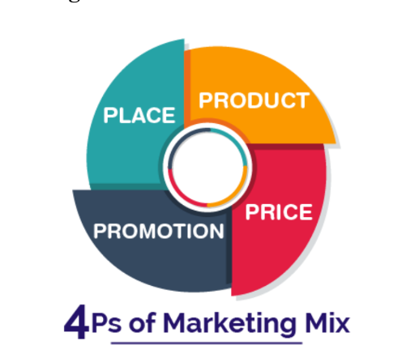

By conducting segment profiling, we can make data-driven decisions on how to approach marketing, sales, and product development for each cluster of electric vehicles, ultimately improving your ability to meet the diverse needs of your target audience.